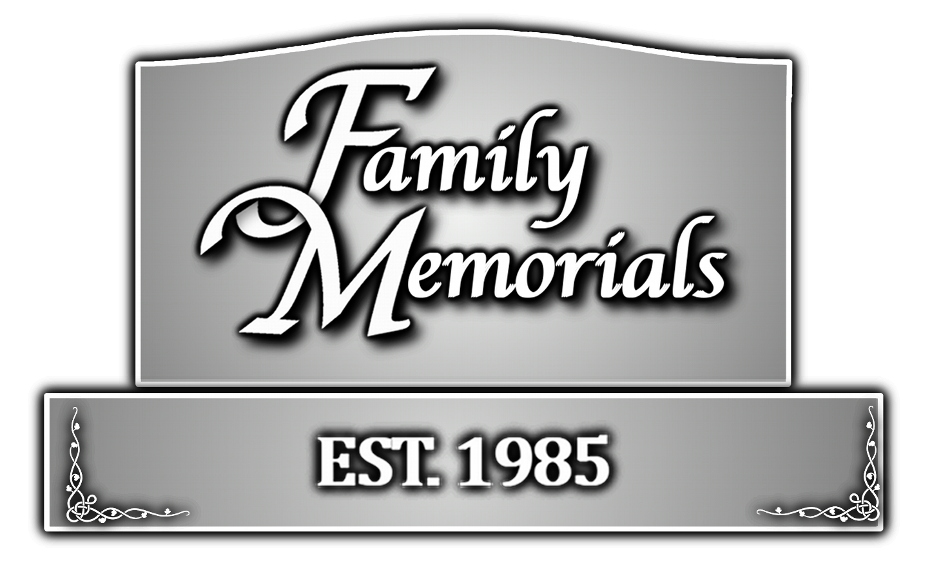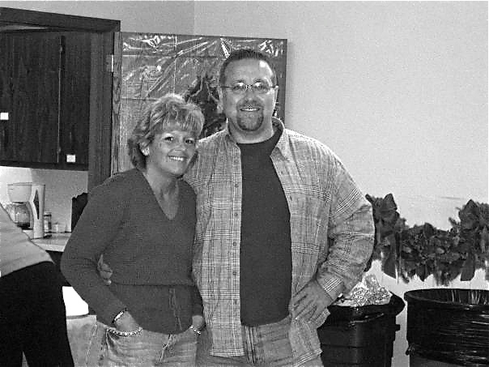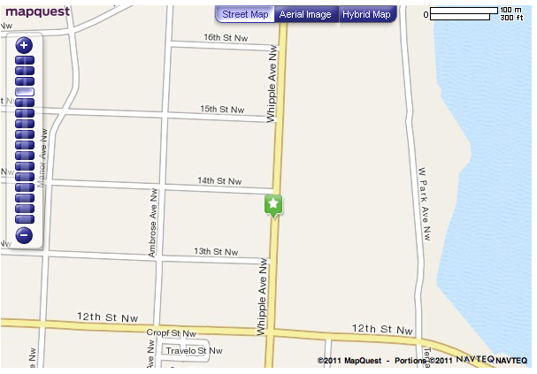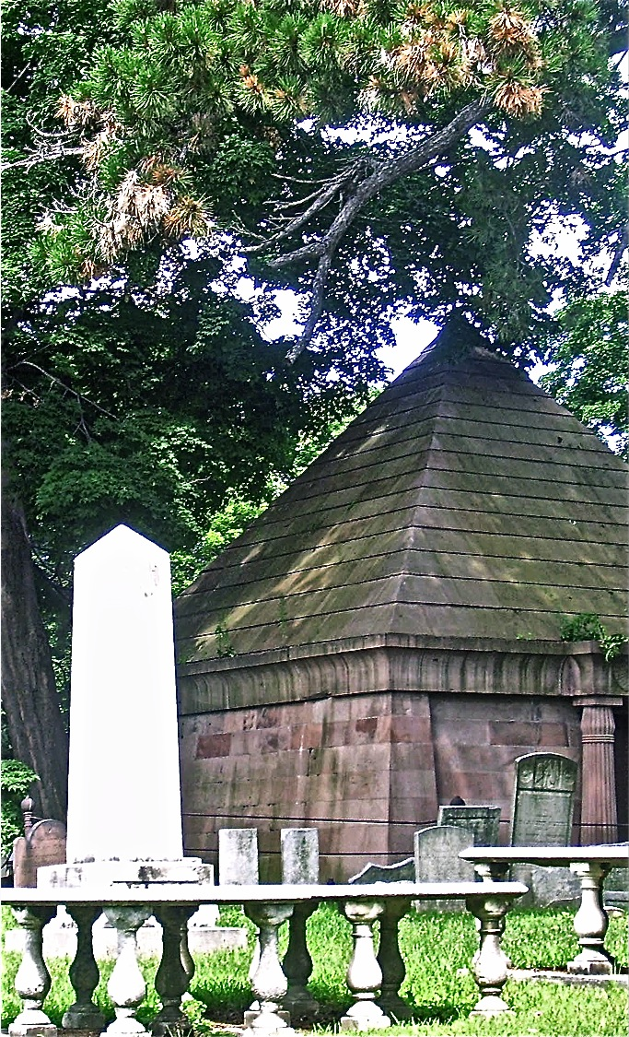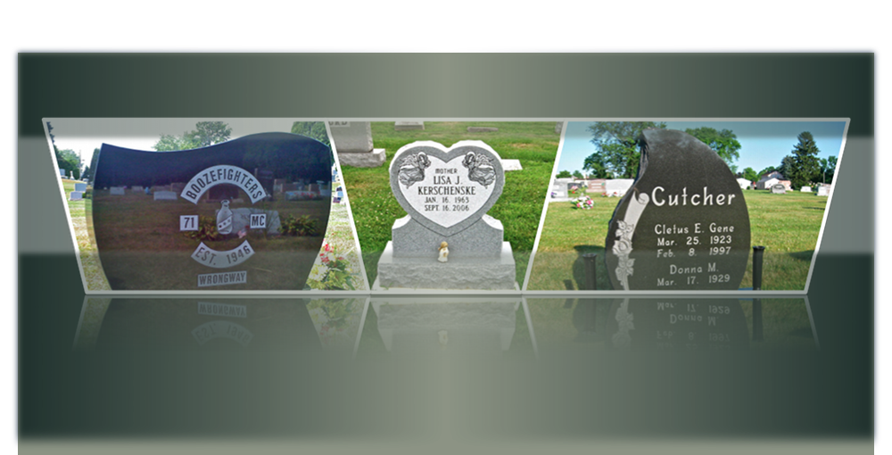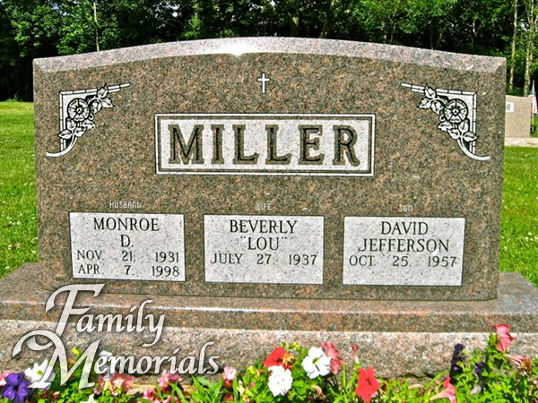

When the time comes to memorialize the life of a loved one, there are many tough decisions to be made. Allow us at Family Memorials to assist you in making that process as smooth as you deserve it to be.

Family Memorials was started in 1985 out of our home on Pigeon Run Rd. We earned the reputation of being honest, fair and compassionate. We are still family owned and operated today.

At Family Memorials, we offer all types of granite memorials and markers in every size and color and a large selection of bronze markers mounted on granite bases. Also in stock are accessories such as vases and memorial flower arraignments – all at very competitive prices.

So stop by and see me (Rick Miller), my wife Melanie or my mother-in-law Carol, and we will help you design a memorial that honors the life of your loved ones. We are located on Whipple Avenue across from the Meyers Lake Plaza.

## **We Care About Families!**

Old Town Cemetery, Newburgh, NY

1325 Whipple Ave., NW   
Canton, OH 44708  
330.477.4900

FamilyMemorialsofCanton.com

Family Memorials

**For all of your monument and cemetery needs!**

Our mission at Family Memorials is to create a meaningful memorial for loved ones passed. We will do this in an affordable manner so that you may have a memorial in recognition of an abundant life once lived. We’ll find unique ways to honor your loved one and in the process offer you peace and comfort throughout this difficult time. We will care for your family with the same compassion and understanding as we would care for our own family.

Planning your estate? Let us help you make pre-arrangement planning comfortable for you. Prearranging cemetery memorial has become a common part of the estate plan for today's families. Planning ahead carries many practical as well as emotional benefits: Locks in the cost of your memorial, regardless of inflation of material costs. Our advance planning assistance is here to alleviate the pressures that can accompany choosing a burial marker by helping you plan ahead.

* Ensures you will receive the type of memorial you want.
* Guarantees your marker fits within the stipulation of your cemetery plot.
* Relieves the stress on your loved ones to make a hard, but important decision at an emotionally difficult time.

# **Advanced Planning Available**

individual they memorialize; you are only limited by your imagination.

**Expert Engraving**

Once the memorial design is complete, we will preserve your memories with quality craftsmanship and a strict attention to detail. Our expert engraver will painstakingly complete your memorial to your exact specifications.

**Cemetery Arrangements & Placement**

Family Memorials will make all necessary arrangements with the cemetery including obtaining and completion all required paperwork. We are familiar with the design policies of area cemeteries and will work with you to be sure your design fits their specifications. We will install your memorial to ensure proper placement. We also do in-cemetery lettering on already placed memorials.

**Financing**

We offer a 0% interest-financing plan to help you afford the memorial your loved one deserves.

**Caring and Compassionate Staff**

Family Memorials is here to help you every step of the way in choosing the right memorial for your loved one while promising to provide attentive, caring service at a fair price. We will be happy to meet with you at your convenience either during business hours or by appointment on evenings and weekends in our showroom. We also offer in-home appointments, if you prefer. Let us help you create a lasting tribute to your loved one that will be treasured and appreciated for generations to come. Our family is dedicated to providing an alternative to the high-pressure sales environment. We offer a relaxed, no-pressure atmosphere that allows each individual the freedom to proceed at a pace that is most comfortable for him or her.

**Complete Design Service**

Our trained staff will help you create the monument that is right for your memories and budget. We will guide you step-by-step through the design process. Our state of the art program will provide a scaled proof design of the monument before it is committed to stone, allowing you the opportunity to preview the memorial and make any necessary edits or changes. Designs can be as varied as the

“Cherishing the memories of our loved ones”

Our Services…